|  |  |
| --- | --- |
| tattoo in traditional style of a d20  COM 688  Final Year Project 2021-22 | Interactive Dungeons & Dragons Character sheet  The goal of this project is the development of a mobile application in which the user can create a 5th edition character sheet for the widely played Tabletop Role Playing Game, Dungeons & Dragons.  Adam Kelso  B00765227 |

Project Study Group – PSG-02

Mentor – Simon Fraser

Course – BSc Hons Computing Science

Table of Contents

Chapter One – Project Elucidation and Statement 3

Project Aims and Objectives 3

Chapter Two – Literature Review 5

Initial Investigation into Problem Area 5

Human Error being a driving point to creating my solution 5

Research into mobile app development 6

Investigation into Similar Solutions 11

Roll20.net 11

DnD Beyond 13

Chapter Three – Project Plan and Requirements Specification 14

Stakeholder identification 14

Requirements Gathering Methodology 15

Requirement Prioritisation 19

System Requirements 19

Functional requirements table 19

Non-functional requirements table 20

Software Lifecycle Methodology 21

Lifecycle of XP 22

Implementation Plan 23

Work-Breakdown Structure 23

Project timeline estimation 24

Gantt Chart 25

Resource Identification 26

Verification Plan 26

Manual Testing 26

User Testing 27

Validation Plan 27

Acceptance Testing 27

Usability Testing 27

Chapter Four - Risk Assessment 28

Chapter Five - Initial Functional Prototype 30

Justification for Risk Selection 30

Design Artifacts 32

Use case diagram 32

Wireframes 33

Prototype Testing Plan 34

References 35

Chapter 1 35

Chapter 2 35

Chapter 3 35

Chapter 4 36

Chapter 5 36

Appendix 36

Appendix 0

Code Manifest 0

# Chapter One – Project Elucidation and Statement

## Project Aims and Objectives

The origin of my final year project idea derives from my hobby of playing D&D, or most known as ‘Dungeons and Dragons’, which I have playing for approximately 3-4 years. Starting from my second year attending my course at Ulster University I have been a member of the official Dungeons and Dragons society[1] having taken part in four different games, or as more officially known as ‘campaigns’; all of these games that I have been engaged in have, as a majority, been played in person on campus; although as of around March 2020 have taken place online on an online platform known as Roll20.net (the name deriving from a die used in various TTRPGs or Tabletop Role Playing Games) which has given me a form of inspiration of what I wish to achieve in my own project as while the website allows users to have a web-based form of their character sheet, one is also given the ability to interact with the sheet to automatically roll the required die and form calculations required for chosen situations such as attacks and ability rolls.

The main issue I hope to address through the development of my application is to streamline the gameplay process. The issue I hope to address is the fact that character sheets are vitally important to the game; unless the player has memorised every intricacy of their sheet, without their character sheet the player cannot play the game. What I hope to achieve is to allow my users to not be required to keep their stats and information on a physical format through a paper character sheet but instead be able to keep their character sheet in an electronic format such as on their phone. Moving on from always keeping their character sheet on them preventing loss of the sheet or simply losing it, I also hope to speed up the character creation and rolling process by allowing the user to create their character directly to the application and once this stage of the application is finished and stable I hope to allow the user to interact with their sheet to automatically roll all required dices and all any related bonuses (I will go into further detail about the application in my project aims).

As for my intended user audience I aim to mainly cover the playerbase of the 5th edition of dungeons and dragons as that is currently the most widely used and currently versions of the game being used as of date as well as the only edition that I currently hold knowledge of; however, come the end of my project, I may upload my project to GitHub and allow others to add upon it as an open-source project.

To break my project down to its base aims and targets for its initial phase it would have to be:

1. allowing the user to create their character sheet using a form which ask them a series of character-building questions such as their characters name, race, and class
2. Once the user has selected their race the system will keep in mind what stat bonus will be added to their base stats in the end
3. The user will then roll four six-sided die keeping the highest three values for a total of six times to create a stat-array which they later assign to each of the six attributes of their character
4. Have the finished character sheet saved as a separate file which the user can use later

Once the initial character sheet system is in place, I hope to go from its initial basic stage into more than just a sheet creator by allowing them to see an interactable sheet which they can click on options to automatically roll their die and add any required bonuses to their roll; by doing this I will allow groups to speed up their turns as they will no longer need to; roll their die, navigate to where on their sheet the needed stat is only to need to try and figure out what they will need to add to a roll, and I’m not done there as they will still need to do the maths in their head to find out their end roll’s total; with my app I hope to take a 1-2 minute process for rolls into 5 seconds.

# Chapter Two – Literature Review

## Initial Investigation into Problem Area

### Human Error being a driving point to creating my solution

##### Physical sheet reliance

One of the largest issues that Dungeons and Dragons players run into is the limiting nature of the physical character sheet medium. By holding all the necessary statistics and information for a character on said sheets the player is hindered by their sheet and is liable to issues such as if they were to travel to a session for their campaign only to find they have forgotten their character sheet as now they will have no way to play their character unless they have memorised their stats.

Through my project, I will offer my users the option to always keep their character sheet on their person by using my app. Through my app players will not only have their character sheets on them at all times in a convenient format but they also will save themselves from needing to print and dispose of redundant sheets on paper format, saving themselves and the planet from wastage!

#### Dice reliance

Much like with character sheets, the art of playing Dungeons and Dragons relies on a specific tool. Setting the scene, you are currently at your friend’s house who is currently DMing[2], or GMing depending on the system of the game in question, and this week you have remembered to bring your character sheet with you; but as you come to start the game you realise that you have left your dice at home! Without their dice a player is unable to make their rolls for their various acts such fighting or even just simple role play; but whilst this can be an issue it is easily fixed by borrowing dice of someone else or sharing with someone near you, although if you constantly need to keep asking to borrow someone’s dice, they may start to get a touch irritated.

One of the main targets of my project is to allow the user to interact with their sheet from the app which will in turn make the use of dice irrelevant as any needed rolls can be fulfilled through the app. Some people however may not always use this feature as some enjoy the feeling of physically rolling their die or may just be in a situation where the Dungeon Master may ask the players to roll in the open to prevent the fudging[3] of rolls.

#### Inclusiveness and Character-building efficiency

A big issue with Dungeons and Dragons is that many people want to try playing the game, but they don’t know how to play or where to start. With my app I hope to mitigate this issue by creating a streamlined and simple to understand form that allows players to create their character without needing to worry about the intricacies of details such as; racial bonuses, updating health and proficiency bonus, etc.; such as system exists on many character sheet creation websites but most of them are static and were created with the intention of making the initial sheet whereas my app has plans to allow the user to simply click a button and select their new features. By using my character creation form users will also be able to quickly make a character again should their other characters die, and they need to quickly make a new one.

### Research into mobile app development

#### What is mobile app development?

According to IBM, mobile application development is the ‘process to making software for smartphones and digital assistants, most commonly for Android and iOS. The software can be preinstalled on the device, downloaded from a mobile app store or accessed through a mobile web browser’. The development of mobile apps is a rapidly growing industry with the world of today having everyone having a smart phone in their pocket; from commercial retail to governments, there is a big need to be able to meet expectations of the public and consumers to provide access to data and transaction in real time and to stay relevant in today’s day and age, businesses must develop mobile apps to meet demand.

Although despite the need to mobile apps in this era, the development of these apps can be quite daunting and scary to attempt to get into with the need to overcome limitations of mobile phone hardware and the hurdles that accrue during the app’s distribution; fortunately, by following some basic guidelines and development practices that have been written and perfected over the last two decades, one can easily streamline their development process.

#### How are mobile apps developed?

In the past the only way to develop mobile apps was to program the application in its platform’s native language, for example for iOS (iPhone and other apple products) one would have needed to use Apple’s explicit development kit. In the development world of today we can use ‘intermediary’ languages such as JS (JavaScript) to build our app so we may export our code to both iOS and Android devices without the need to develop the apps separately saving us both time and money!

One kind of mobile app that is create is known as ‘Native Apps’, these are apps which are built and developed for the sole use of a specific operating system meaning they must conform to the requirements of the OS and are not interchangeable with others; an example of this is iOS apps not being useable on Android devices. Apps such as these are typically downloaded from the device’s respective app store although this is not as limiting for android devices as they can download apps using APKs from the internet whilst iOS devices cannot. Native apps tend to run better and offer a better user experience due to the app being developed for a set list of conventions such as user interface and knowing the hardware of the users the app is being created for.

Another kind of app is hybrid or HTML5 apps, these apps are built using HTML, JavaScript, and CSS; these languages are mainly used for the development of websites which is why these apps are commonly seen as ‘glorified websites’ put into a mobile app format. These apps are cross-device able, so they are quite favourable in the eyes of companies and businesses that want to save money and time, these apps however are not as fast as native apps

#### What Languages are used for mobile app development?

1. Java - One of the most popular languages used in the world is Java, it is a powerful and robust language that is great for server-side and boasts the largest number of open-source projects by developers! This language can be used for iOS development, though it is more often used for the creation of android apps due to its use amongst developers and its flexible use which is a large boon for the freedom and creativity of android when compared to the more conservative iOS; also, there are already several different development tool for it on android.
2. JavaScript – JavaScript has been a ‘long-time favourite’ (apparently?) among developers for the development of mobile apps, with some saying that it is the best language, end of. It has greatly rose to fame amongst app development thanks to the release of frameworks such as Vue and React.js which allow developers to create front-end components. A large positive for the use of JS in app development is its ability to be run on all devices which makes it great for hybrid apps which can save you so much time in development! Due to JS being around for an estimate of 25 years, it has large community that release numerous plugins and frameworks which really helps streamline development.
3. Swift – Swift is a free, open-source language developed by Apple which has surpassed even C as the preferred language for the development of mobile apps. Swift is a very readable and type-safe language which makes it very easy to get into unlike other languages such as C; it is also very interactive, meaning you can work in an interactive environment and see the output of your code whilst developing it, which is great for testing or catching errors.
4. Kotlin – Kotlin is a new player on the board, and works as a great alternative to Java, it is also the official language of Google which is good as android devices use Google for their app store (known as play store). Kotlin also has native support, and it is supported by IDEs such as Android Studio and IntelliJ IDEA. There are those who say that Kotlin will become the next Java, but it is still a new language and has plenty of time to grow and is good language to learn due to its strong endorsement by Google.

#### How can I develop mobile apps?

We can develop mobile apps by using specialist programs used for software development know as IDEs or integrated development environments. Developers use a series of different tools during development and IDEs allow them to have all the tools needed to create the software from text editors and code libraries, to the test platforms and compilers needed to run the code. The main use of IDEs is the source code editors, these editors allow for ‘highlighting syntax for better readability and classification. It also autocompletes the code for you, which has fastened the coding process, reduced the stress of remembering the correct syntax for each and everything, and increased the productivity of programmers as well’.

When it comes to developing mobile apps there are several different IDEs available to help do so, some of which include:

1. Android Studio – Android studio is the official IDE build for the sole purpose of enhancing the development process and allowing for the creation of high-quality Android apps. Based on the IntelliJ IDE, AS allow you to add code and change resources whilst running the app so you can test your app on the fly without needing to re-run the code and suggests code whilst you type. Another big Android Studio feature which people look for when developing apps is the ability to emulate a device to install and run your app on so you can prototype your apps and see how they look on different devices. Android Studio allow provides a drag and drop editor which developers can use to quickly add elements to their app without needing to manual type the code into a file like other languages such as HTML; this feature allows presents the developer with a view of the screen which the user can tinker with to set aspects such as layout constraints. Another great feature of Android Studio is the ability to generate APKs for devices for easy export and provides ‘build automation, dependency management, and customizable build configurations. It also has the integration of version control tools for teamwork and has a unified environment’.
2. XCode – XCode is the IDE of choice for the development of Apple iOS apps which allows for the creation, testing, and optimisation of the apps before submitting them to the Apple App Store. XCode boasts a single window interface which allows the developer to have access to all their tools on the one page such as their coding editor, UI design, asset management, testing, and debugging respectively. XCode also offers its users an editor what highlights mistakes and offers to fix them automatically whilst also providing code snippets and ready-made file templates so speed up the creation process. ‘XCode provides extensive documentation on using XCode, and it provides much more that includes SDK doc, programming guides, tutorials, sample code, detailed framework API references, and more’.
3. Visual Studio – VS much many other code editor IDEs offers highlighting of syntax and the auto-completion of code but were VS ventures off on this topic is its use of IntelliSense which allows for the suggested completion of code based on the variable types, function definitions, and import modules. VS also allows for the debugging of code using break points so you can go through the debugging process one step and a time. Another great selling point for Visual Studio is its built-in GIT commands from its terminal within the code editor, allowing for easy pushing and pulling from any hosted SCM services. In terms of customisability when using VS if need be you can ‘install various extensions that will run in separate processes making sure your editor isn’t slowed down. You can add new languages, themes, debuggers, and additional services as well’.
4. IntelliJ – IntelliJ much like many other IDEs in this list offers:
   1. Deep Intelligence: After your code is indexed by IntelliJ IDEA, you receive relevant code suggestions, code completion, runtime code analysis, and refactoring tools.
   2. No plugins needed: Important tools like integrated versions control systems and support for other languages and frameworks are already integrated without the developer having to add plugins.
   3. Framework-specific assistance: IntelliJ, although a Java-centric IDE, also provides smart coding assistance for other languages including SQL, HTML, and JavaScript.
   4. Automation: With the IDE predicting your requirements and automating the menial and time-consuming tasks, your productivity as a developer increases and so does your focus.
   5. Ergonomics: IntelliJ makes sure the developer’s flow isn’t interrupted and it follows your context to bring up the corresponding tools automatically.
   6. Built-in-tools for mobile dev: Since we are discussing the best mobile development IDEs; IntelliJ supports Android, React Native, Cordova, and Ionic.
5. Xamarin – Xamarin is a cross-platform development tool which completely free and open-source! It is an app development platform based of the use of .NET and C# for Android and iOS systems; by using Xamarin you can:
   1. Easily share code across multiple platforms such as Android, Windows, macOS, and iOS between mobile, web, and desktop apps.
   2. Leverage the iOS and Android library such as C and Java through Xamarin
   3. As the IDE uses .NET, one has access to the extensive community libraries available such as SQLite, Polly, and more!

## Investigation into Similar Solutions

### Roll20.net

An extremely popular platform used by many TTRPG players is a website called Roll20. Roll20 acts as a website that allows its users to host and play games in many different systems giving its users the ability to use different features for their games such as maps for combat or a ‘journal’ menu in which the host of the game can allow their players to view character sheets for information or even edit their own character’s sheet.

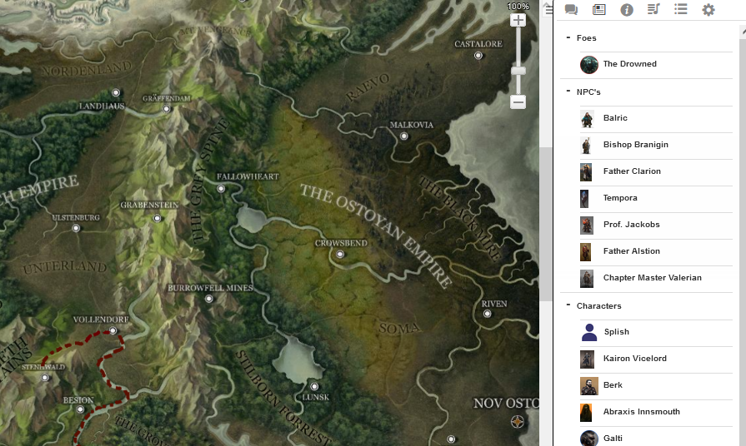

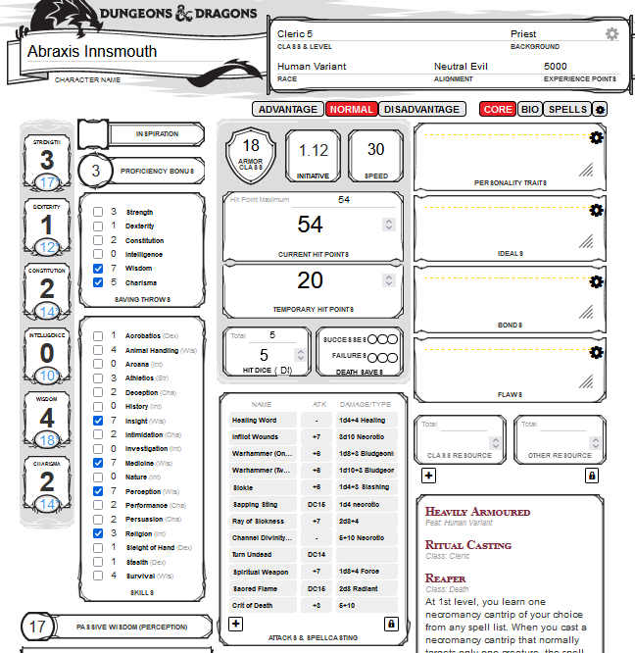The biggest draw that Roll20 has is its character sheets; the reason why they are so popular is because they allow the user to click aspects on the sheet to automatically roll the required dice and updates things such as a characters proficency bonus which makes the website very welcoming to new players as it means that they don’t need to fully understand how to roll their die. It was Roll20 which I used when I played Dungeons and Dragons for the first time as since the game was being run online, I was able to play in a game run my a friend of mine located in America. It is the interactive character sheets of Roll20 which as has acted as the biggest source of inspiration for my project; in the same way that roll20 has allowed me to learn to play D&D I want my app to allow other people to be able to learn in the same way I did. People might wonder why I would create an app that does the same thing as the Roll20 character sheets, but there is the issue of paid membership for roll20; without a paid membership, users are unable to offically use the games from a moble device so I want to create an app that will allow people to use their character sheets from their mobile without the issue of payment aswell as the fact that the character sheets used on Roll20 is bound to the singular game that it has been added to but my app won’t have that issue.

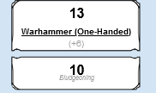

### DnD Beyond

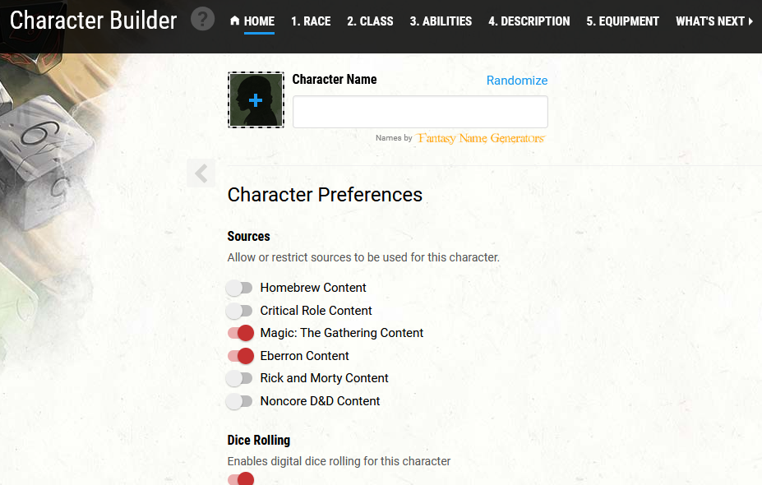Another option that people may go for is DnD beyond due to its automatic linking to the Dungeons and Dragons source books. I have don’t have much knowledge on the campaign running aspect of the website, I do however know a little about the character creation aspect of the site; the way that creating a character works on the website is by either creating a first level character based off recommended starting options, making a random sheet, and the other last option involves a character creation wizard that allows the user to select specific options such as; level, race, class, and the wizard will automatically put together the information for the sheet linked to the options selected such as racial bonuses and class features.

However good the D&D Beyond website is for creating characters and running games with its automatic access to the source books is there is an issue, and that issue is that most of the the books are not available without payment which makes the site not very useful if the user is not willing to pay to access the non default books offered which is especially an annoyance should the user own the books in a physical form or not own the books through the DnD beyond website. What I hope to take from the site is the character creation aspect as while the Roll20 site has its own version of the character creator that DDB has, it is not as sopisicated and is in my experience quite unstable and prone to messing up the character sheets assigned to players if the creator is closed incorrectly which is why if an user wishes to just create a sheet it is a good idea to use DDB as I have found it quite reliable (as long as the sheet will not require races,features, or class not included in the base D&D system).

# Chapter Three – Project Plan and Requirements Specification

## Stakeholder identification

In a business or a project there are groups on people that hold an interest in its’ success, these people are known as stakeholders because as you can guess they hold a stake in the idea or business. The reason WHY they tend to hold a stake in the success in which we will use a secondary school as our example is because they have something to gain from the school existing where it is; around a school you will find a variety of different stakeholders such as: residents and business owners, when the school is running well as intended this means that the residents of the area have access to a local school in which they can send their kids to or a business owners have a constant flow of customers which will visit their store before and after school or during lunch breaks; they all gain from the schools success.

For my project the first and most obvious internal stakeholder is me myself the developer of the project, as I will be the one working on the project from start to finish from inception to its final handover; I will obviously want the project to succeed, not just because my mark depends on it but also because I want this app to succeed for my own use and the use of others. The second stakeholder of my project is Simon Fraser, whom is my mentor for my project, because he will be providing guidance over my project and critique any inefficiencies in my process and keep me on the right track during my project’s lifecycles.

In terms of external stakeholders in my project they would have to be my end users. In the end it will be my users that will be using the app so they will be hoping that the project is completed successfully without issue; currently the users I have in mind will hopefully consist of the Dungeons and Dragons society who I hope to have test my app when it is in its testing stages and will be the ones I hope will give me requirements for the application that I may have missed as who better to tell me what is needed than the ones that will use it. My final group of stakeholders will consist of my Peer Support Group as they can help shape my project by giving advice and moral support in my project and can possibly act as testers for my app leading to consistent users when the project is finished.

|  |  |
| --- | --- |
| *Name* | *Role* |
| Adam Kelso | Project Lead / Lead Developer / Designer /  Research / Testing |
| Simon Fraser | Project Advisor |
| Dungeons and Dragons Society | User / Testing / Design |
| Peer Support Group | Support / Advisor / User |

## Requirements Gathering Methodology

To gather the main requirements for my project I have used three main methods to narrow them down. The first stage of collecting the requirements of my app came into place during my initial discussion with my study advisor Simon Fraser in which we initially spoke in a meeting as I was yet to have thought up an idea for my project which would have been viable to work on; it was Simon that brought up the topic on Dungeons and Dragons which sparked the idea of creating mobile character sheet which users could interact with on their phone. Once I had the idea of what the basis of my project was going to entail the second of which was thinking up what the base mandatory features the application would have based off what I would want to have in the app if I was the one using it which led me to planning the main features such as creating the sheet, rolling, etc. which allowed me to create the base raw bare minimum stage of what my app should be able to do.

Once I had the base features in my plans I moved on to thinking up more features that I could add at a later date once the main focus of the application is developed, but I ran into a roadblock here as I was unable to thinking of any ideas; it was then that I remembered the discussion that I had with Simon about project ideas were he made the suggestion that as I am part of the university’s D&D society I may be able to use them as a test group for my application. Once I had discussed this idea with members of the society’s committee I was given the green light to ask the members of the society with their assistance; once I had attained a list of 10 people, most of which consisted of my own campaign group, I sent out an email to my stakeholder users a link to a google form in which they answered a series of questions on their experience playing D&D with two final questions asking them for any ideas that they may have for features for my app and if they would be willing to test the app once it is in its prototype phase, which has been quite the success as everyone that I have sent the questionnaire to has had great ideas and is willing to test the app.

Question 1 – What is your name?

(***for data protection I will not be revealing their response to this question***)

Question 2 – How long have you played D&D

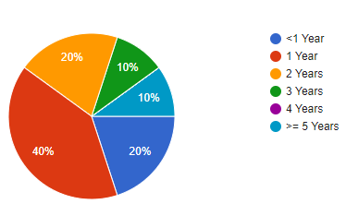

Question 3 – How often do you play D&D

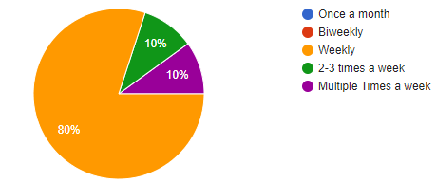

Question 4 – How do you use your character sheet?

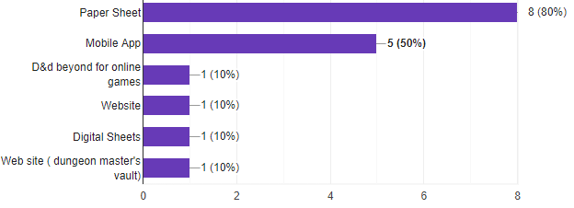

Question 5 – If you use an app for your sheet, does your app allow you to roll?

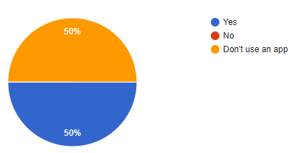

Question 6 – How long does it take you to create a character sheet?

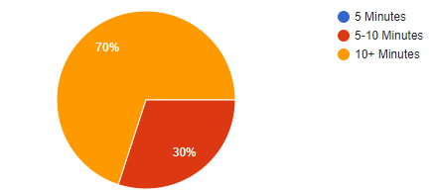

Question 7 – The current features planned for the app include being able to create a character using a form, being able to roll the necessary die and add modifiers by using the sheet and export the sheet to PDF for possible printing. Do you have any requirement ideas?

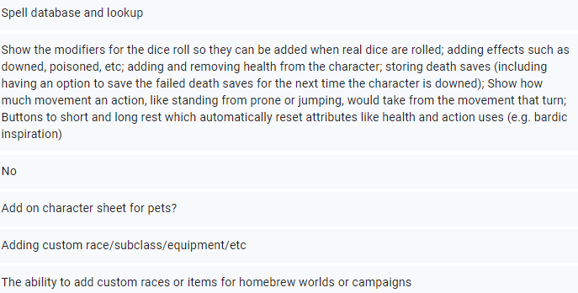

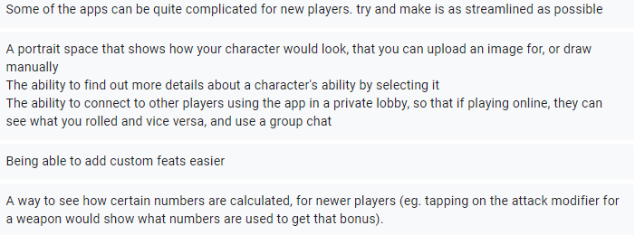

Question 8 - Would you be open to testing the app once it is in its prototype stage?

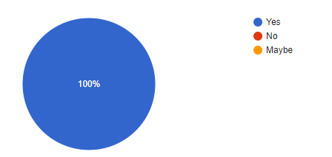

## Requirement Prioritisation

After some consideration, I have come to the decision to prioritise specific features of my application to achieve a successful prototype phase of my project. In order in confidently saw I have fulfilled my vison of my project at its most base barebones functionality; the point of the application is to give the user the ability to have a character sheet on the app and be able to interactive with said sheet to roll die, as for the other bells and whistles such as character creation forms and exporting the sheet to a PDF format, I cannot continue development to implement these quality of life features if the base character sheet and roll mechanics (the main purpose of the app) if I have not covered the most foundational requirements of my app. Once I have achieved the starting required features of my app as advertised I indeed to move on from this point to try and implement the additional requirements as has been suggested by my testing control group to attempt in differentiating myself from other applications on the market that share features like my own product.

## System Requirements

After preforming their methods of application requirements, the developer must now set out a list of requirements for their project; with these lists being functional requirements, and non-functional requirements.

To explain to those who are not fully clear on the definition of these two types of requirements, functional requirements refer to a set of functions that are present in the product that are required for the function of the application itself such as for my project a functional requirement would be; ‘The application must be able to roll to required dice when a user tries to roll to attack’.

Meanwhile we also have non-functional requirements which refer to less-mandatory functions such as quality of life (QoL) features, which refers to features of a product that are not mandatory for the use of said product but instead exist to offer a more enjoyable and high-quality experience of the product such as ‘application must give the user the option to use buttons to quickly access intended features without having to look through a cluttered interface’. While this feature would be good to have in the application, it is not mandatory for the use of the app but instead serves to make the app cleaner and more refined.

### Functional requirements table

|  |  |
| --- | --- |
| Requirement No. | Requirement |
| F1 | The application must have a UI designed for mobile devices |
| F2 | The application must have a UI designed for tablets |
| F3 | The application must allow the user to create a character |
| F4 | The application must allow the user to interact with the sheet to roll |
| F5 | The application must be able to store a character sheet |
| F6 | The application must allow the user to generate a character using a creation wizard |
| F7 | Character sheet should have a level-up button that should automatically update health based on chosen class |
| F8 | User should have drop down options to select their race/class but also a custom option to allow for custom class/races/subraces |
| F9 | Rolls done through interaction should show the breakdown of the roll |
| F10 | Character sheet attacks should be expandable to tell you user that the attack is doing i.e., swinging a sword, or casting a spell |

### Non-functional requirements table

|  |  |
| --- | --- |
| Requirement No. | Requirement |
| NF1 | The application should automatically add features linked to chosen class on level-up |
| NF2 | The application should run quickly |
| NF3 | The application should run smoothly |
| NF4 | The application should have a clean UI that allows the user to select specific section headers to only show the sections that they are wanting to access such as attacks, skills, etc. |
| NF5 | The application should always show the stat block at the top of the screen |
| NF6 | The application must allow the user to interact with the sheet to roll |
| NF7 | App should be inclusive of most kernel versions of Android |

## Software Lifecycle Methodology

When it comes to the development of software there are several different methodologies out there that can be used, examples of such include Agile, SCRUM, Rapid Application Development, and waterfall. After giving some thought to the different methodologies available to me and my project I have decided that based on the time and scale of my project that I will be using the software methodology known as XP or ‘Extreme Programming’ which is an agile cycle focused on the improvement and quality of the developed software based on constantly changing user requirements. I mainly chose this methodology due to my limited time frame for my development due to needing to juggle other coursework for my university course and the fact that I alone will be developing this software, I also chose this methodology as the constant change in customer requirements is to be expected with my project as there will be other features and other requirements for my application as development continues.

The lifecycle of XP is much like other agile-based methods in the sense that it is focused on the development of small versions of software that will be released on a planned schedule such as sprints, with the intention of constantly building upon the previous sprint until a satisfactory product is created or development is completed. The XP cycle is much more based on the development of working code as apposed of to the production of documentation.

### Lifecycle of XP

The lifecycle of XP is based on five processes:

* Planning – This is the first stage of the Extreme Programming cycle, user stories and/or requirements are drawn up at this stage. These stories and requirements will be taken and used to create the features and functionality that we will need to have in our completed product. Once we have planned our requirements, we can begin an estimation of time and any costs of our development and plan out our sprints.
* Designing – Our next stage in the cycle is designing our software, the lifecycle of XP is based on trying to keep the designs of our software as simple as we can with extra functionality not being added as we will hope to not add such features until later in development. As the refactoring of code is a core part of this stage of the lifecycle, we must work on code reusability to attempt to cut down of redundant code we must use system metaphors for our naming conventions; by doing so we can, through the development of the product, keep the quality and understandability of our product much better.
* Coding – A strong emphasis in this third stage of the lifecycle is the focus on coding standards so that we may keep our code consistent so that it may be easy to understand and refactor. The XP lifecycle says that we should try to integrate code almost daily so that any issues and/or incompatibility may be found and worked out early in production.
* Testing – As the XP model works on the continuous feedback and changing requirements of the users, it is important to ensure we receive quality feedback so we may make that our testing is ‘up to snuff’ which is why driving our development based of our tests is the best way to implement test-driven development. For our testing we have to main ways to implement our tests, unit testing which the art of testing our product based on each individual feature of our program with each test needing to pass for our development to be complete. The other kind of testing is user/customer testing which is more acceptance testing and for XP development this kind of testing is engaged for each iteration of development.
* Listening – The final stage of our XP cycle is engaging in the customer/user involvement as the overall success of the product is based on the developer(s) being able to take said feedback from users and making sure that said feedback and requirements are properly implemented in the product. I should have little issue with this as I have a test group in place that will test my app as development continues.

## Implementation Plan

As I mentioned earlier in the report Extreme programming is the methodology that is to be used in the project and the main development of the product after my initial prototype will be broken into weekly iterations or phases of development and if weekly updates are not available, I will try to make them at biweekly intervals.

### Work-Breakdown Structure

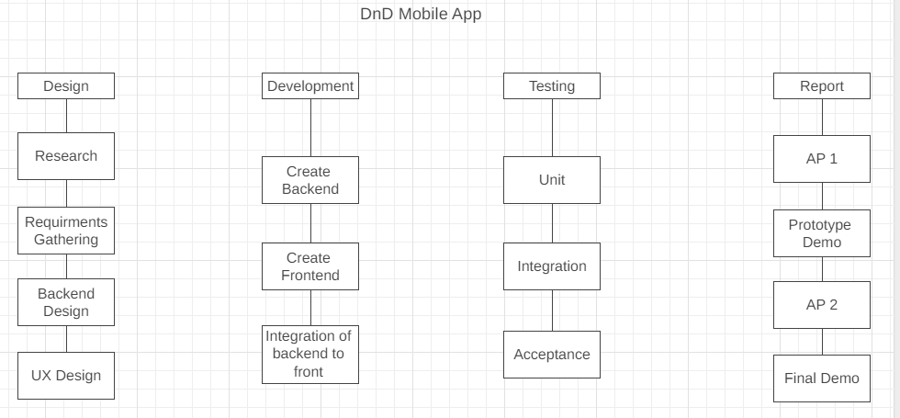

### Project timeline estimation

Overall, for the project there are 30 weeks to complete it and I have broken the workload down into the following rough table on estimated timelines for meeting deadlines.

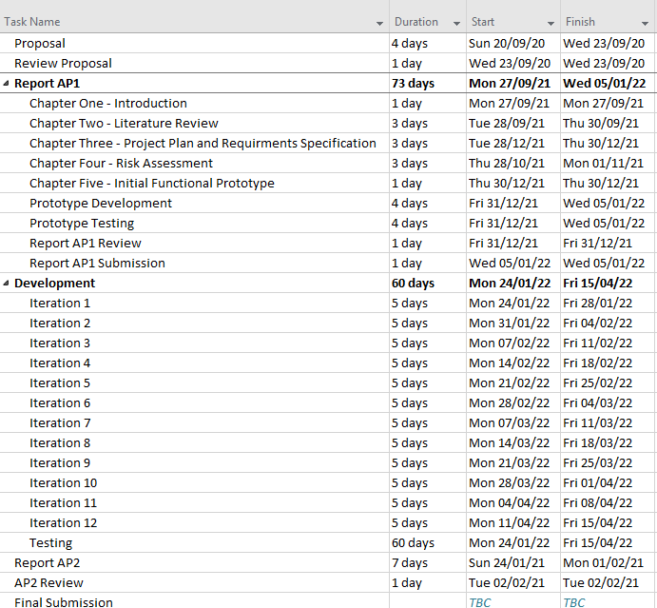

The dates shown in this table are purely theoretical and contains dates for starting and ending. At the stage I am currently at, I estimate the project to run until around the ending of April; of course, this is again a mere estimate and is subject to delays and stoppages to development due to other coursework. The development of the app has been broken down into 12 iterations but again yet another estimate and may have more or fewer iterations based on how smoothly production goes and receiving a more concrete deadline for the final submission. Testing of the application will be constant throughout the creation of the app and any new features and important iterations will be pushed to my test group to get their feedback on if they believe everything works as intended or needs further refinement. On the follow page I have included a Gantt chart to show the timeline of the dates of my project in a more abstract calendar like format.

### Gantt Chart

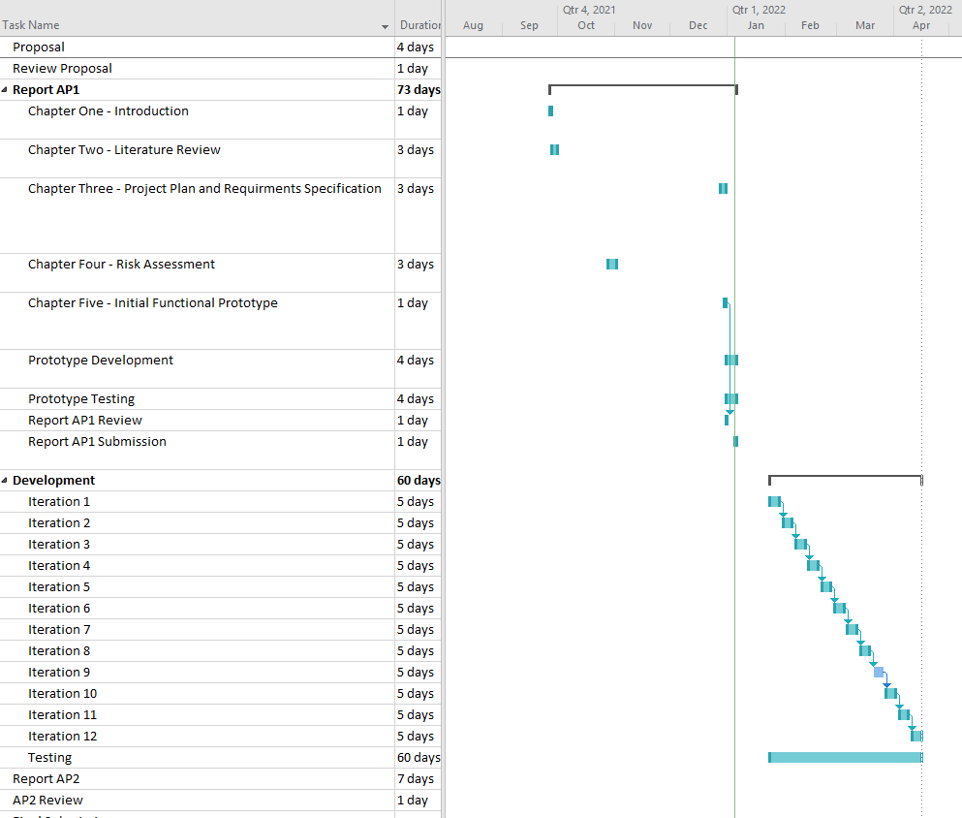

## Resource Identification

Resources:

* Laptop
* Mobile Phone
* Tablet
* IDE
* Java

The laptop that will be used to develop the app will be the developers’ own machine and will be used for both developing the application and testing the application in a PC environment. In terms of the mobile phone, a Huawei P20 lite, will be used to test the application on an actual phone as opposed to the emulator built into the IDE; the IDE being used to develop the app at this time is planned to Android Studio and this current stage unless any issues arise in development. As mentioned, Android Studio is the IDE to be used during this project with the code being written in Java. ‘Android Studio provides a unified environment where you can build apps for Android phones, tablets, Android Wear, Android TV, and Android Auto. Structured code modules allow you to divide your project into units of functionality that you can independently build, test, and debug’.

## Verification Plan

Verification testing is something takes place during the development phases of a product, they are a set of tests that are undergone in to ensure that product is meeting the requirements of the of the specific iteration or sprint in that part of development. The point of these test is so that the developer(s) can take the time to ask themselves if they are doing the job correctly and making the right product. During this project there are going to be two main methods of testing I will be engaging in during the testing of my application.

### Manual Testing

Manual testing refers to the process of using features and the application as a user would to verify that the application works as intended. During the verification process I will be manually testing my application through a series of test cases in to make a series of different start to finish tests much like the ones I created and engaged in during my time on placement. These test cases will involve a step-by-step instruction on how to complete the test with a series of expected outcomes and an area to note the actual output of the stage; these test cases will be sent out to my test group so that they can easily complete the tests with little interaction from the developer.

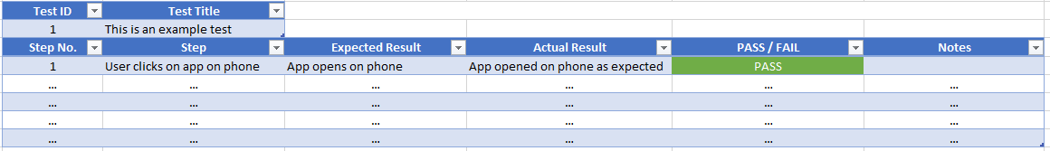

### User Testing

During the development of my project, I will be pushing any new versions of my app containing new features to my test group so that I can receive any feedback or issues with the application in real-time as well as receive accurate responses on what issues they have run into by using the test cases that I will develop and sent out and filled in by my test group. It is these kinds of test cases which we used during our testing of the mobile app that was being developed during my placement and were sent out to our test users so we could get the required feedback needed to be passed on to the developers.

## Validation Plan

Validation is the process which takes place once we have reached the end of our development process to evaluate our product to see if we have met the requirements specified during our planning and ask ourselves if we are making the right product as if we have not met the requirements that we have listed during our planning we have not successfully created the correct product. In the end the validation stage comes down to making sure the application meets the need of its users which shouldn’t be too much of an issue as if I am not meeting the needs of the users then my testers will let me know as they are the target user base.

### Acceptance Testing

Acceptance testing refers to testing the mind of whether the product meets the user’s needs and requirements to see if the feature or product satisfies the acceptance criteria and allows the development team to enable the user/client to see for themselves if the product should be accepted into the system or should go back to further development.

### Usability Testing

Usability testing can be said to be quite like acceptance testing as they both involve users testing the product and using their feedback to better the application, although the difference between the two is that while acceptance testing is focused on the identification of bugs that exist in the current version/build of which can be classified as beta testing, usability testing focuses on the identifying of the usability of the application by the actual users that will be using it as to validate our application it must be easy to use by those who don’t know how it works as strongly as the developer that may be testing it.

# Chapter Four - Risk Assessment

When it comes to working or starting a project there are several different risks that can pose a threat, but it is the mark of a good project planner to be able to take these risks into mind and make the effort to try and mitigate these risks. A good thing about my software development cycle is that the Extreme Programming allows for uncertain requirements due to its ability to cater to ever changing requirements. Although my project has defined requirements planned from the beginning it is not a bad idea to be able to adapt to new requirements and plan further ahead, this is because further requirements and suggested features can crop up during development or existing ones may need to be changed or even dropped altogether.

Another way that XP help mitigate our risks is, as the cycle has use constantly testing our code before it is used on a large scale; we are able to mitigate integration issues that may cause issues later in development. In a risk assessment a developer should be able to identify the risks that may appear during their project, how it will affect the project as a whole, and the steps they should or will take to mitigate these risks, the following table lists some of the risks that have come to mind during the planning of the project which shall also be kept in mind during development to see what further risks must be looked into to test if they will pose a threat later in production or may be mitigated to the point where they are no longer a threat due to related risk mitigations.

|  |  |  |  |
| --- | --- | --- | --- |
| *Risk ID* | *Risk* | *Risk Threat Level* | *Mitigation Plan* |
| *1* | Developer is unable to develop the app correctly | *Low* | Given the timeframe given and the number of resources available to the developer this risk is of little threat as there is a plethora of options to choose from should assistance be required |
| *2* | Developer runs into issues and falls behind schedule | *Medium* | If necessary non-mandatory features can be cut from development to be added as a later iteration or after the initial deadline of the project |
| *3* | Developer finds issues in developing front-end of app which delays development | *Small* | Android Studio provides a drag and clickable interface in which the developers can use to create the front-end UI for the application so the only issue that may arise is getting said UI to link to the back end. |
| *4* | Developer runs into an issue with version control and messes up code | *Small* | Issues with the code will be mitigated by hosting the version control of the code on GitHub so that any issues can be rolled back should the need arise not including the use of branches to keep the main branch safe during the addition and testing of new features. |
| *5* | The developer lacks experience working with mobile app development | *Small* | The developer will research into tutorials for creating mobile apps to gain a better understanding of the workload they are working with. Also, the initial prototype will allow the user to get a feel for how the mobile development works which may drop this and other related risks entirely |
| *6* | The application contains hidden bugs that go unnoticed | *Small* | The plan for the application is planned to be quite small scale so the likelihood of such bugs existing in unlikely and even if they did, they wouldn’t be a threat to the app as if they were, they wouldn’t go unnoticed during testing. |
| *7* | Developer has never created a mobile app before and has no experience with exporting program | *Small* | The developer will research into tutorials for creating mobile apps to gain a better understanding of the sharing of applications such as using APK packages, and the prototype will allow the user to get a feel for how this works as they will need to export the app to their phone for testing. |
| *8* | Developer may find that new features and requirements may mess with development and lead to delays | *Medium* | As said before should issues arise during development, annoying features can be dropped for a later date or until they can be implemented at some other point should the code of another feature help solve the issue. It is not the developer’s intention for this app to be complete after the coursework in submitted as it is intended to be worked on beyond that deadline. |
| *9* | App being based on Android systems may lead to a lack of usable test users | *Small* | Requirements acquisition in person has found that most if not all test users own an Android phone, should users not own an Android phone they can always use a tablet instead or have one provided during a meeting to test there in that moment. |
| *10* | The developer has never done a project like this before | *Medium* | While the developer has never done a project like this before it is a great learning experience to expand their skillset; also, the developer has a multitude of resources available such as their project study group if they need assistance. |

# Chapter Five - Initial Functional Prototype

## Justification for Risk Selection

The point of this prototype is to show some of the intended functionality of our project and to address some of the listed risks that have been identified previously within this report. The prototype created intends to attempt to address the following identified risks:

|  |  |
| --- | --- |
| *Risk ID* | *Risk* |
| *5* | The developer lacks experience working with mobile app development |
| *7* | Developer has never created a mobile app before and has no experience with exporting program |

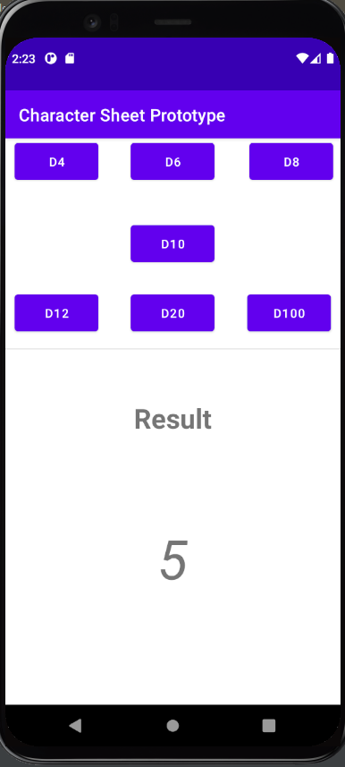

The risks listed above were chosen due to their biggest significance to jeopardise the initial development of the project as well as to present a sense of validity in the projects development and to show competence in the development as to have made the effort to have attempted to mitigate these risks and to have made some progress in their development, by showing some functional features of the intended requirements. The produced prototype has allowed the developer to gain some experience in the development of mobile applications and the usage of the Android studio IDE.

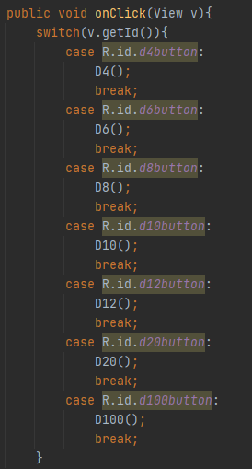The main feature of the prototype will allow the user to access a dice roller activity in which users will be able to roll the seven dice used whilst playing D&D (D4, D6, D8, D10, D12, D20, D100). These rolling options are accessed using buttons which once clicked trigger a onClick() reaction which will feed the id of the button pressed into a switch that will call the associated method related to that button. While this being on only real functionality to the app currently being present can be seen as a lack of development this feature is purposed first and foremost to mitigate the listed risk stated above; and whilst to those whom have not much knowledge of D&D may think that just having a dice roller is lacking, rolling these dice sets the functionality for an estimate of 90% of playing D&D; now that I have a functional dice roll, I can now reuse this premise later in production when it comes to skill and stat rolls to simple run this method and then add the associated the modifier scores and/or proficiency bonuses which will make my codebase much more efficient as it will cut down on redundant and repetitive code.

The following requirements will be relevant to my prototype build of my project; although for the sake of the prototype not having a full character sheet, I will give requirement F4 some leeway an allow myself to count the buttons on the dice roll page as the ‘sheet’.

|  |  |
| --- | --- |
| Requirement No. | Requirement |
| F1 | The application must have a UI designed for mobile devices |
| F2 | The application must have a UI designed for tablets |
| F4 | The application must allow the user to interact with the sheet to roll |
| F9 | Rolls done through interaction should show the breakdown of the roll |

Ultimately whilst the prototype may viewed as lacking functionality wise when compared to the intended functionality identified in the beginning of the report, the main bones of the project have been developed which will allow for easier development in the future and it is with the experience gained during the initial creation of the prototype that the developer is able to take what they have learn to create a better version/build of the application in later iterations.

## Design Artifacts

### Use case diagram

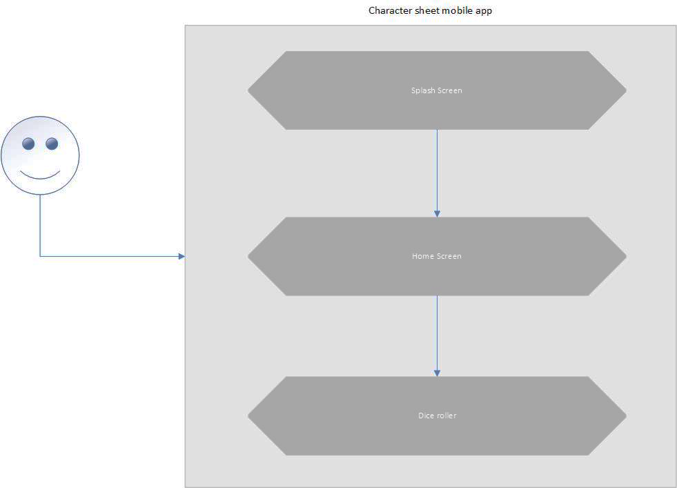

The use case diagram shows the use of the application and how the user will be taken through the prototype. The user begins when they open the app by being taken to the splash screen which is the screen that will be displayed whilst the app loads in the background, this splash screen at this moment is quite basic but will be updated to look more professional once the main development past the prototype stage has begun. When the splash screen has finished the user is taken to the main page of the app which at this moment contains a testing phase of the character sheet, when the tests are continue it is intended to allow the user to change the main stat values for the character and have the modifier for each stat automatically update in real-time but for now it is still in development; when the user looks to the bottom of the screen they will see a button that will take them to the dice roller page. On the dice roller page, they will see seven different buttons that will roll the corresponding die and present the result at the bottom of the screen.

### Wireframes

|  |  |
| --- | --- |
|  | The purpose of this page is to act as a home page of the app once the users have finished loading the app and getting passed the splash screen. The user will be able to click a button in the top left that should open the navigation panel to navigate to other pages; this button and panel is intended to be on every page for easy navigation between activities even if the wireframe does not show it. |
|  | The purpose of this page is to give the users the ability to roll normal dice without the modifiers that they may have been using in the character sheet page. These rolls may be used if the user needs to just make simple rolls, or they may want to make a d100 roll for example if they are trying to roll for a reward from a table. |
|  | This page is intended to be the main page of the application, where the user will be able to have a character sheet present on the page in which they can select different elements of the sheet to roll the needed die and add the necessary modifiers automatically; currently this page is not fully developed in the prototype and is only present in a test phase. It is intended for the characters stats to be always shown on the top of the screen whilst below a series of buttons should be present to present the corresponding menus for other information such as skills and action rolls. |

### Prototype Testing Plan

|  |  |  |  |  |
| --- | --- | --- | --- | --- |
| Test ID | Test | Expected Result | Actual Result | PASS / FAIL |
| 1 | Does the app open? | User taps on app in menu to open and the app opens without crashing | App opens without crashing | Pass |
| 2 | Is the user taken to the main activity screen on open? | User is presented app splash screen and then taken to the main page once app has finished loading | User is shown splash screen and is taken to main screen | Pass |
| 3 | Can the user interact with the app? | User can tap on buttons on the screen and interact with the text input field on the main screen | Buttons are functional and tapping on the input field allows for typing | Pass |
| 4 | Does tapping the ‘Dice Rolls’ button take the user to the activity? | User is taken to dice rolls page once corresponding button is clicked on main page | Button navigates user to dice roll page | Pass |
| 5 | Does selecting a button generate a number and print it to the results below? | User clicks on button and a random number is generated and presented below in the results area | Clicking a dice button successfully presents a random number below | Pass |
| 6 | Does the generated number generate within the correct range? | User clicks on dice buttons and the generated number is within the set range of the die | After several uses of the button all generated results are within the expected range for each dice | Pass |

# References

## Chapter 1

*None*

## Chapter 2

Ibm.com. n.d. *Introduction to Mobile Application Development*. [online] Available at: <https://www.ibm.com/cloud/learn/mobile-application-development-explained> [Accessed 3 January 2022].

D'Ambra, S., n.d. *How Mobile Apps Are Built*. [online] ClearTech Interactive. Available at: <https://www.cleart.com/how-mobile-apps-are-built.html> [Accessed 3 January 2022].

Webiotic. 2021. *Best Language For Mobile App Development—What You Need to Know - Webiotic*. [online] Available at: <https://www.webiotic.com/best-language-for-mobile-app-development-what-you-need-to-know/> [Accessed 3 January 2022].

Appverticals. 2020. *Best IDEs for Mobile App Development | Our Top 5 Picks*. [online] Available at: <https://www.appverticals.com/blog/best-integrated-development-environments/> [Accessed 3 January 2022].

Roll20.net and dndbeyond.com for screenshots taken for investigation into other solutions

## Chapter 3

ReQtest. 2012. *Functional vs Non-Functional Requirements - Understand the Difference*. [online] Available at: <https://reqtest.com/requirements-blog/functional-vs-non-functional-requirements/> [Accessed 30 December 2021].

AltexSoft. n.d. *Functional and Nonfunctional Requirements: Specification and Types*. [online] Available at: <https://www.altexsoft.com/blog/business/functional-and-non-functional-requirements-specification-and-types/> [Accessed 30 December 2022].

Leau, Y., Loo, W., Tham, W. and Tan, S., 2012. *Software Development Life Cycle AGILE vs Traditional Approaches*. [online] Available at: <https://www.researchgate.net/profile/Leau-Yu-Beng/publication/268334807_Software_Development_Life_Cycle_AGILE_vs_Traditional_Approaches/links/546989b40cf2f5eb1804f3d1/Software-Development-Life-Cycle-AGILE-vs-Traditional-Approaches.pdf> [Accessed 30 December 2021].

Digite.com. n.d. *What Is Extreme Programming (XP)? - Values, Principles, And Practices*. [online] Available at: <https://www.digite.com/agile/extreme-programming-xp/> [Accessed 30 December 2021].

Novoseltseva, E., 2017. *Extreme programming; tips & advantages - Apiumtech*. [online] Apiumtech. Available at: <https://apiumtech.com/?p=5111> [Accessed 30 December 2021].

Android Developers. n.d. *Android Studio features | Android Developers*. [online] Available at: <https://developer.Android.com/studio/features> [Accessed 30 December 2022].

Connected-corridors.berkeley.edu. n.d. *System Validation and Verification Plans | Connected Corridors Program*. [online] Available at: <https://connected-corridors.berkeley.edu/developing-system/system-validation-and-verification-plans> [Accessed 31 December 2021].

SOFTWARE TESTING Fundamentals. n.d. *Manual Testing - SOFTWARE TESTING Fundamentals*. [online] Available at: <https://softwaretestingfundamentals.com/manual-testing/> [Accessed 31 December 2021].

SOFTWARE TESTING Fundamentals. n.d. *Acceptance Testing - SOFTWARE TESTING Fundamentals*. [online] Available at: <https://softwaretestingfundamentals.com/acceptance-testing/> [Accessed 31 December 2021].

SOFTWARE TESTING Fundamentals. n.d. *Usability Testing - SOFTWARE TESTING Fundamentals*. [online] Available at: <https://softwaretestingfundamentals.com/usability-testing/> [Accessed 31 December 2021].

## Chapter 4

*None*

## Chapter 5

*None*

## Appendix

Android Developers. n.d. *App Manifest Overview | Android Developers*. [online] Available at: <https://developer.Android.com/guide/topics/manifest/manifest-intro> [Accessed 5 January 2022].

# Appendix

## Code Manifest

|  |  |  |  |
| --- | --- | --- | --- |
| ***File*** | ***Purpose*** | ***Was the file created or modified?*** | ***Statement of contribution*** |
| Java/com.final.project.app/MainActivity.java | The purpose of this file is the java code that runs for the main activity page. The code on this page sets the layout for the page based on the activity_main.xml file and contains the code that loads the DiceRolls activity when the method to open the page is called. | Modified | I contributed to this file by adding the code that is called by an onClick event set on the button that opens the DiceRoll activity. |
| res/layout/activity_main.xml | This file contains the XML code that controls the layout of the activity_main page. This code contains instructions such as the constriction values that control the positioning of elements on the page in relation to other aspects of the page such as the parent view or other elements such as buttons and/or text | Modified | Whilst this page is automatically created on the creation of an app, I was the one that added much of the code in the file whilst adding elements to the page. |
| Java/com.final.project.app/DiceRolls.java | This page serves as to hold the code for making rolls in the app. The plan for this file is to hold all the rolls for the app which will be called when needed by other pages. The current version of this file contains the methods for each dice roll which creates a randomized number in the specific range of the dice and sets the .text value of the result presentation label as the roll result after being converted to a String; the file also contains a switch which calls the corresponding dice method based on the ID of the button that called it | Created | I contributed all the code in this file with the partial assistance of StackOverflow as to find a way to make my buttons work with a switch as opposed to having a create view for each roll type which was cause null pointer errors while this switch was implemented to fix this error it also made my code for pressing the buttons more efficient. |
| res/layout/activity_dice_rolls.xml | This file contains the XML code that controls the layout of the activity_dice_rolls page. This code contains instructions such as the constriction values that control the positioning of elements on the page in relation to other aspects of the page such as the parent view or other elements such as buttons and/or text | Created | This file was created by me (technically) on the creation of the dice rolls page, much like the main page’s xml file I provided the code in this file whilst creating the front end for the page by adding elements and creating the constraints |
| Manifests/AndroidManifest.xml | ‘The manifest file describes **essential information about your app to the Android build tools, the Android operating system, and Google Play**. Among many other things, the manifest file is required to declare the following: The app's package name, which usually matches your code's namespace’ | Modified | The only modifications I have made to this file is the android:label value as to change the label that names the app icon on the phone to be clearer and more professional |

1. https://www.uusu.org/organisation/uusudanddsoc/
2. The act of running a tabletop role playing game as the controller of the story through the role of Dungeon Master or Game Master
3. Cheating a roll by rolling again for a better outcome if the original roll brings an undesired outcome; often used by DMs to prevent massacring players if enemies are rolling too well